SCHOOL OF COMPUTER SCIENCE AND ARTIFICIAL INTELLIGENCE |  |  |  |  | DEPARTMENT OF COMPUTER SCIENCE ENGINEERING
Program Name: B. Tech |  |  |  | Assignment Type: Lab |  |  | Academic Year:2025-2026
Course Coordinator Name |  |  |  | Dr. Rishabh Mittal
Instructor(s) Name |  |  |  | Mr. S Naresh Kumar  Ms. B. Swathi  Dr. Sasanko Shekhar Gantayat  Mr. Md Sallauddin  Dr. Mathivanan  Mr. Y Srikanth  Ms. N Shilpa  Dr. Rishabh Mittal (Coordinator)  Dr. R. Prashant Kumar  Mr. Ankushavali MD  Mr. B Viswanath  Ms. Sujitha Reddy  Ms. A. Anitha  Ms. M.Madhuri  Ms. Katherashala Swetha  Ms. Velpula sumalatha  Mr. Bingi Raju
CourseCode |  |  | 23CS002PC304 | Course Title |  | AI Assisted Coding
Year/Sem |  |  | III/II | Regulation |  | R23
Date and Day  of Assignment |  |  | Week11 – Wednesday | Time(s) |  | 23CSBTB01 To 23CSBTB52
Duration |  |  | 2 Hours | Applicable to  Batches |  | All batches
Assignment Number:21.3(Present assignment number)/24(Total number of assignments)
 | Q.No. | Question |  |  |  |  |  | Expected Time  to complete
 | 1 | Lab 21 – Collaborative AI Coding: Pair Programming and Version Control Integration  Lab Objectives:  - Learn to use AI as a pair programmer for writing, reviewing, and optimizing code.  - Understand how to integrate AI-generated code into version control systems (Git).  Practice collaborative workflows such as commit messages, branching, and merging. |  |  |  |  |  | Week11 - Wednesday
Task 1 – AI-Assisted Pair Programming
Example:
Use AI to generate an initial Expense Tracker Application.
- Ask AI to create a basic program to record daily expenses and categories.
- Prompt AI to suggest improvements such as:
  - Monthly expense summary
  - Input validation
  - Code refactoring into functions
- Compare the initial and improved versions to understand AI’s role in collaborative coding.
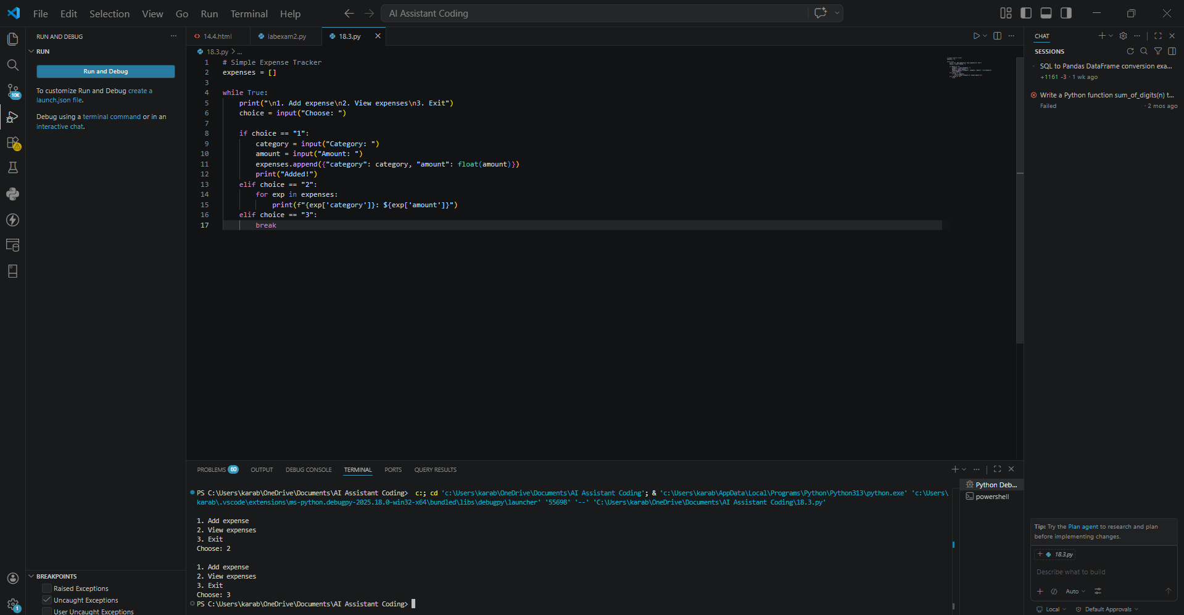
PROMPT:
EXPLAINATION: The program lets users enter daily expenses with categories
It stores data in variables or lists.
The improved version:
- Calculates total/monthly expenses
- Checks invalid input (like negative numbers)
- Uses functions to organize code

Task 2 – Version Control Integration
Example:
Manage a Student Grade Calculator project using Git.
- Initialize a Git repository for the project.
- Create a new branch to add AI-assisted features such as:
  - Grade classification
  - Average and percentage calculation
- Commit changes with meaningful commit messages.
- Merge the feature branch back into the main branch and resolve conflicts if any.
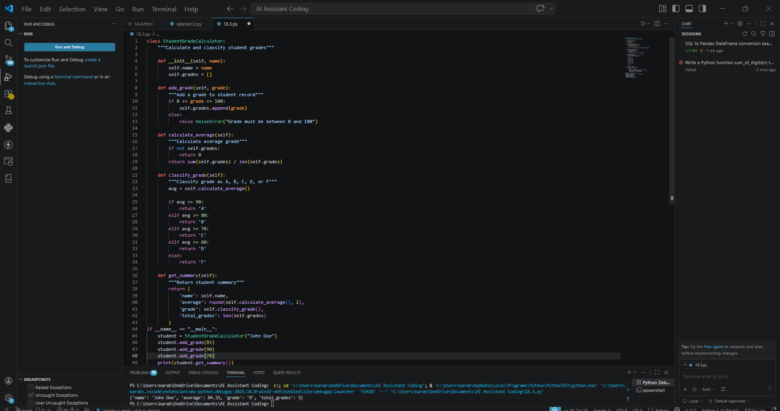
PROMPT: Help me use Git for a Student Grade Calculator. Add grade classification and average, write commits, and merge branches.
EXPLAINATION: Help me use Git for a Student Grade Calculator. Add grade classification and average, write commits, and merge branches.

Task 3 – AI for Commit Message Generation
Example:
Use AI to generate commit messages for a Password Validation Module.
- Modify the code to add rules like:
  - Minimum length
  - Special character requirement
- Ask AI to generate commit messages describing these updates.
- Compare AI-generated messages with human-written ones and analyze clarity.
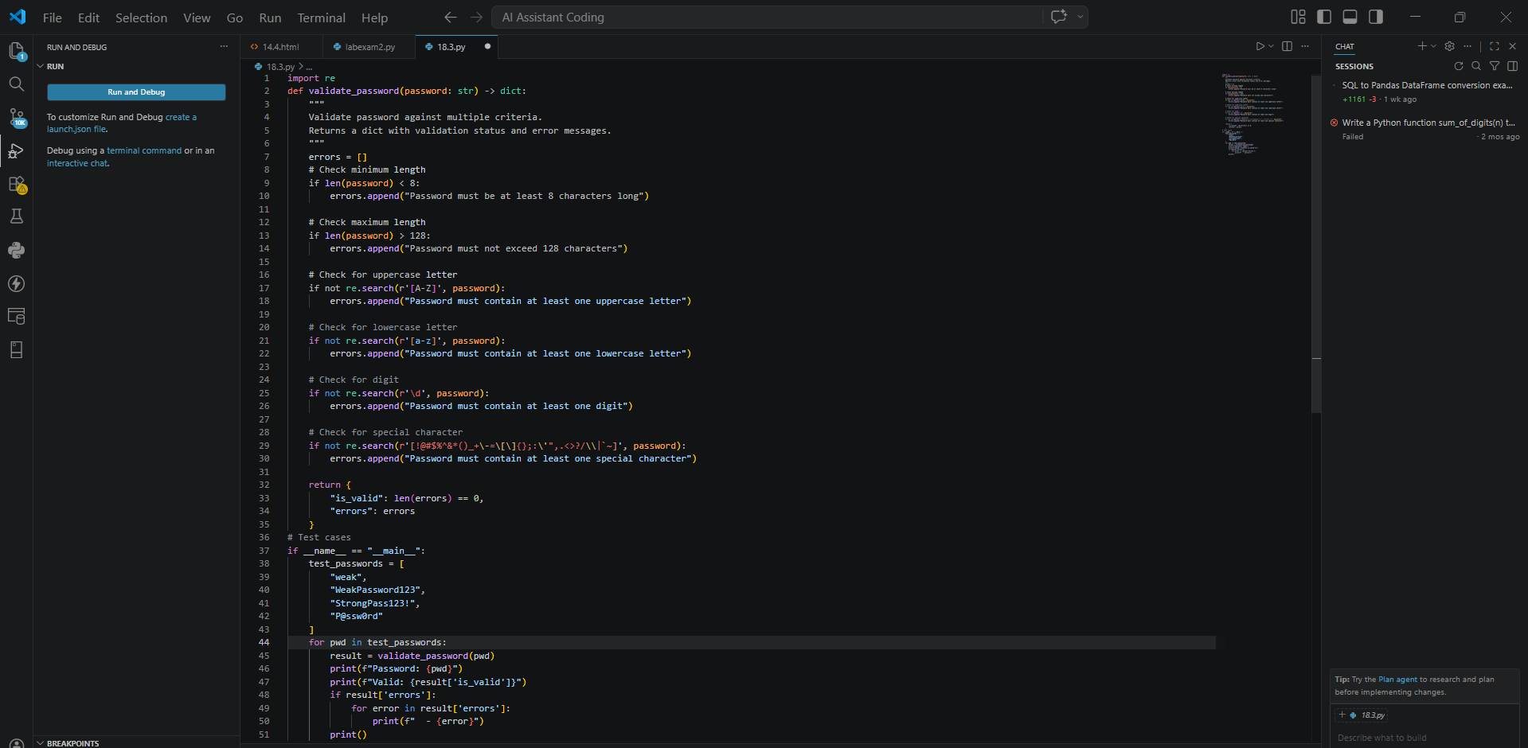
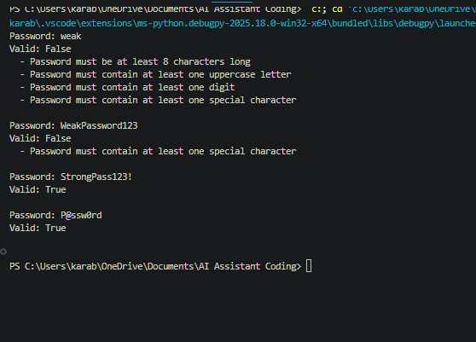
PROMPT: improve a Password Validator with length and special character rules. Generate clear commit messages and compare with human ones.
EXPLAINATION: The program checks if a password is valid.
Added rules:
- Minimum length
- Must include special characters
AI helps generate clear commit messages explaining changes.
Shows how AI improves documentation and clarity.

Task 4 – Pair Programming Simulation
Scenario:
Collaboratively develop a Quiz Management System.
- Student A creates the initial quiz program with questions and answers.
- Student B, with AI assistance, adds features such as:
  - Score calculation
  - Input validation
- Both students collaborate using Git branching and merging to integrate their changes.
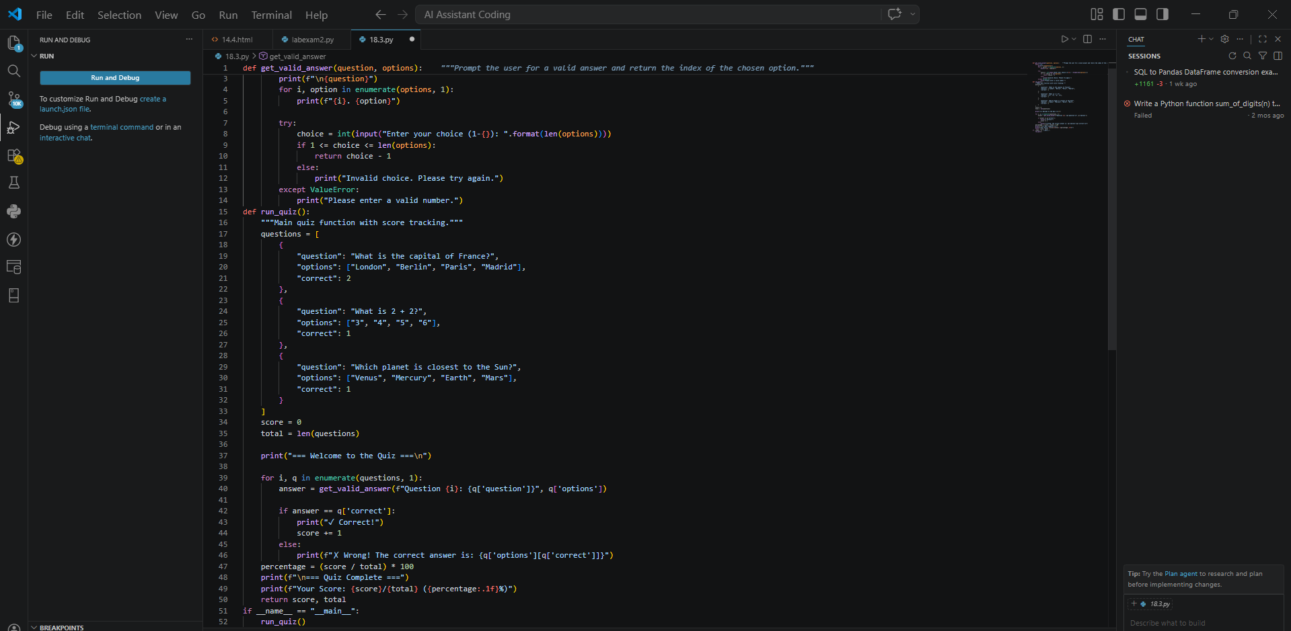
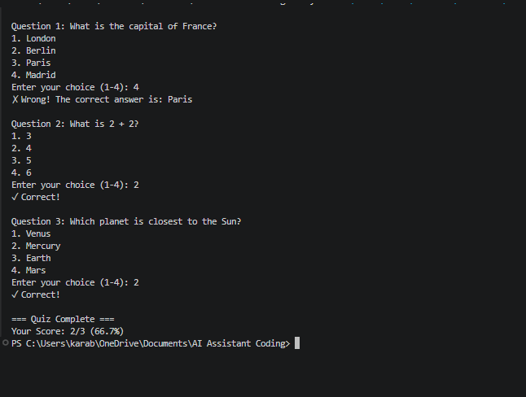
PROMPT: Create a basic Quiz program, then add score and validation. Show how to use Git branches and merge changes.
EXPLAINATION: Basic program asks questions and checks answers.
Improved version:
- Calculates score
- Validates user input
Work is divided:
- Student A → basic quiz
- Student B → improvements using AI
Git is used to combine both parts

